Department of Computer Science



PROJECT DOCUMENTATION

CLASS: IIIrd B.Sc Computer Science
SEMESTER: V
ACADEMIC YEAR: 2026–2027 SUBJECT CODE: 26NMITA
SUBJECT NAME: Service Now - It Service Management and AI Emphasis.

PROJECT TITLE: Import Data using Transform Maps (Spreadsheet).

COLLEGE NAME: Syed Ammal Arts and Science College.

COLLEGE CODE: ALUAU41

TEAM ID: SWTID-2026-1694

TEAM MEMBERS: [Team Size: 5]

MANSOOR RAHMAN ( T E A M L E A D E R )
AHAMED APSAR K
MOHAMED MUJAHITH D
RAVI SANKAR S
SATHEESWARAN K

PROJECT OVERVIEW

Import Data using Transform Maps is a ServiceNow-based micro project designed to import structured employee data from an external spreadsheet into the ServiceNow platform.
The project uses Import Sets and Transform Maps to efficiently transfer employee information from an Excel spreadsheet into a custom ServiceNow table. The spreadsheet data is first loaded into an Import Set table, which acts as a staging area. A Transform Map is then used to map the source fields to the corresponding target table fields.
After transformation, the employee records are created or updated in the target table. The project also uses Coalesce to prevent duplicate records during repeated imports. Reports and dashboards are created to provide visual information about employee data.

PROBLEM STATEMENT

Managing employee data manually can be time-consuming and may lead to duplicate records and data inconsistencies.
When employee information is received through external Excel spreadsheets, manually entering every record into ServiceNow requires additional effort.

This project solves the problem by:
- Importing employee data from Excel.
- Creating an Import Set table for temporary data storage.
- Mapping source fields to target fields using Transform Maps.
- Automatically inserting and updating employee records.
- Preventing duplicate records using Coalesce.
- Creating reports and dashboards for better data visualization.

OBJECTIVES

The main objectives of this project are:

- To import employee data from an external spreadsheet into ServiceNow.
- To create a custom Employee Test table.
- To create an Import Set table for employee data.
- To configure a Transform Map between source and target tables.
- To map employee fields correctly.
- To use Coalesce to avoid duplicate records.
- To verify inserted and updated records.
- To create reports based on employee data.
- To create a dashboard containing the generated reports.

CORE TECHNOLOGIES USED

- ServiceNow – Platform used for implementing the project.
- Import Sets – Used to load external spreadsheet data into ServiceNow.
- Transform Maps – Used to map and transform source data into the target table.
- Custom Tables – Used to store employee information.
- Excel Spreadsheet – External source containing employee data.
- Coalesce – Used to identify existing records and prevent duplicates.
- Reports – Used to analyze employee information.
- Dashboards – Used to display reports in a centralized visual interface.

SYSTEM ARCHITECTURE

The project consists of the following major components:

- EXTERNAL DATA SOURCE

Employee information is prepared in a spreadsheet containing fields such as Employee ID, Employee Name, Email, Department and Location.

- IMPORT SET TABLE

The spreadsheet data is loaded into the Employee Import table. This table acts as a staging area before the data is transformed.

- TRANSFORM MAP

The Transform Map connects the Employee Import table with the Employee Test table. Source fields are mapped to their corresponding target fields.

- TARGET TABLE

The transformed employee records are stored in the Employee Test table.

- COALESCE

Coalesce is enabled on an employee field to identify existing records and prevent duplicate records during repeated imports.

- REPORTS AND DASHBOARD

Reports are created using the Employee Test table and are combined into an Employee Analytics Dashboard.

PROJECT WORKFLOW

Excel Spreadsheet
↓ Load Data
↓
Employee Import Table
↓ Transform Map
↓
Field Mapping
↓
Transform Data
↓
Employee Test Table
↓
Coalesce – Duplicate Prevention
↓ Reports
↓
Employee Analytics Dashboard

PROJECT IMPLEMENTATION
PHASE 1: PREPARE THE SPREADSHEET

- A new spreadsheet is created with sample employee data.
- The spreadsheet contains employee information required for the ServiceNow project. After preparing the data, the spreadsheet is downloaded in Excel (.xlsx) format for importing into ServiceNow.

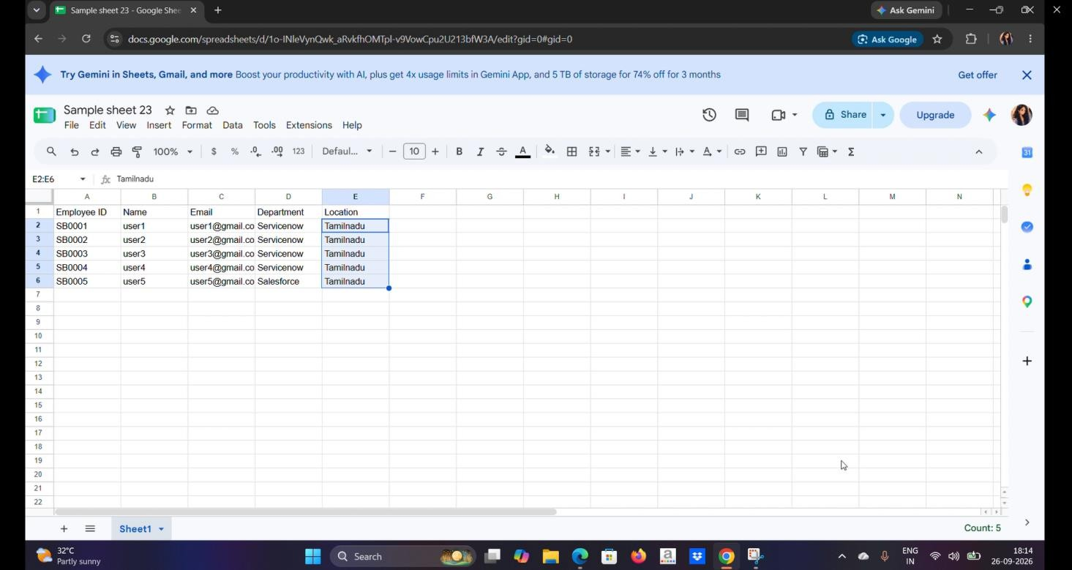

PHASE 2: CREATE CUSTOM TABLE
- A custom table named Employee Test is created in ServiceNow.
- Table Details:
- Label: Employee Test
- Name: u_employee_test
- The required fields are then created:
- Employee ID
- Employee Name
- Email
- Department
- Location
- All fields are configured as String fields.

PHASE 3: CREATE IMPORT SET TABLE
- The Load Data option is opened from the Application Navigator.
- An Import Set table is created with the following details:
- Label: Employee Import
- Name: u_employee_import
- The spreadsheet data can then be loaded into this Import Set table.

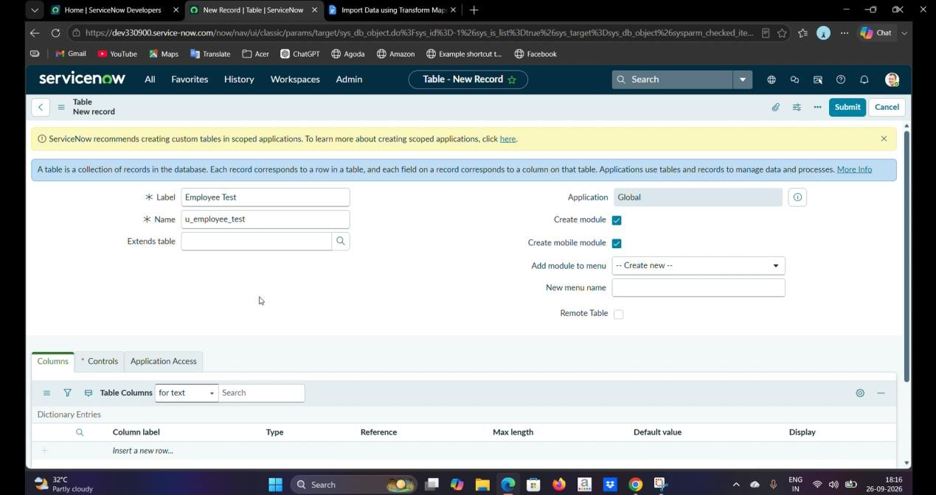

PHASE 4: CREATE TRANSFORM MAP
- A Transform Map is created to transfer data from the Employee Import table to the Employee Test table.
- Transform Map Details:
- Name: Sample Spreadsheet Import

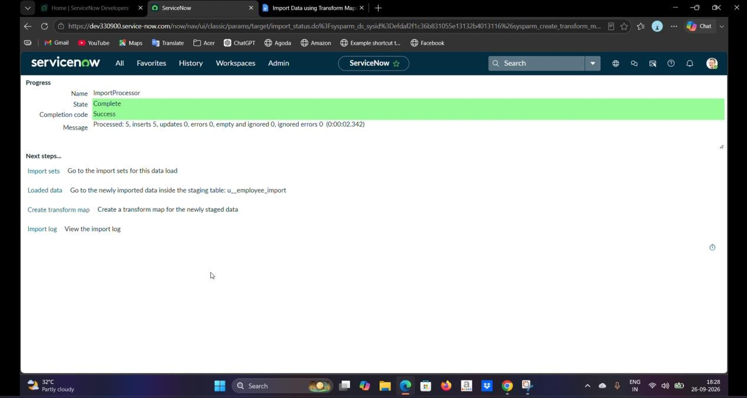

- Source Table: Employee Import
- Target Table: Employee Test
- Auto Map Matching Fields is used, followed by Mapping Assist to map the source and target fields.

- The field mappings are then saved and the transformation is executed.

PHASE 5: TRANSFORM DATA AND VALIDATE
- After running the Transform operation, the imported records are verified in the Employee Test table.
- The records created through the import process are checked to confirm that the employee information has been successfully transferred.
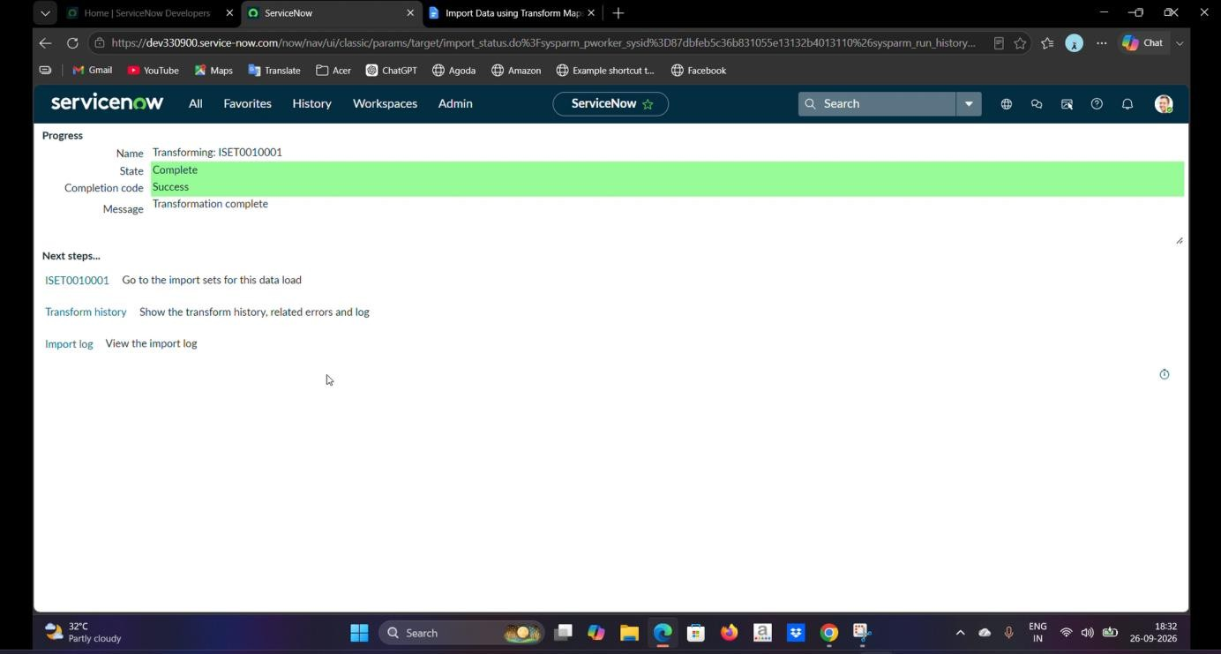

PHASE 6: ENABLE COALESCE

Coalesce is used to avoid duplicate employee records when the same data is imported multiple times.

The created Transform Map is opened and a field in the Field Maps section is configured with Coalesce = True.

When the same Employee ID is imported again, the existing record can be identified instead of creating an unnecessary duplicate record.

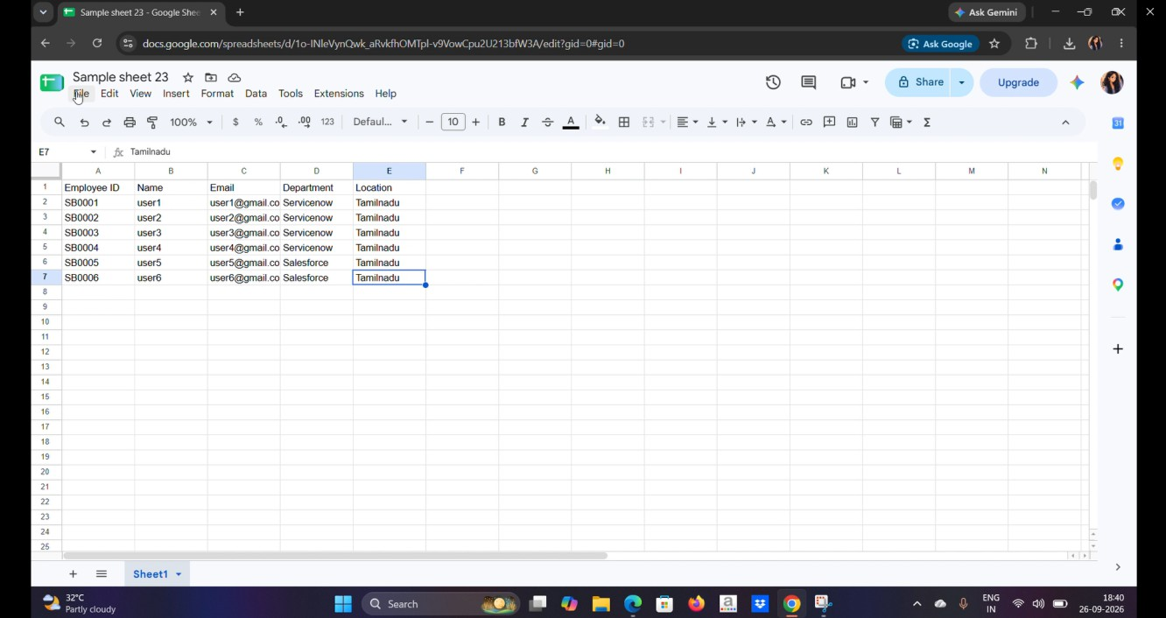
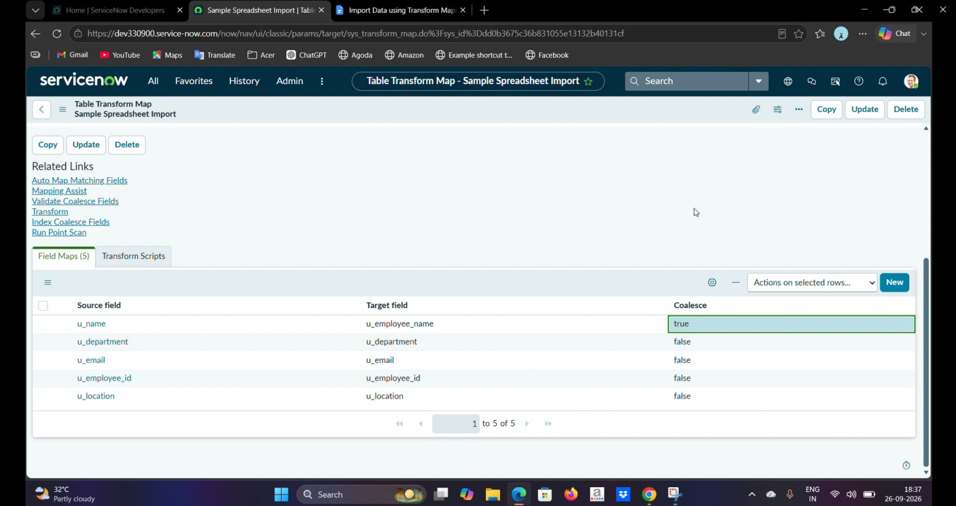

PHASE 7: INSERT AND UPDATE DATA

New employee data is added to the Excel spreadsheet and imported again using the existing Employee Import table.

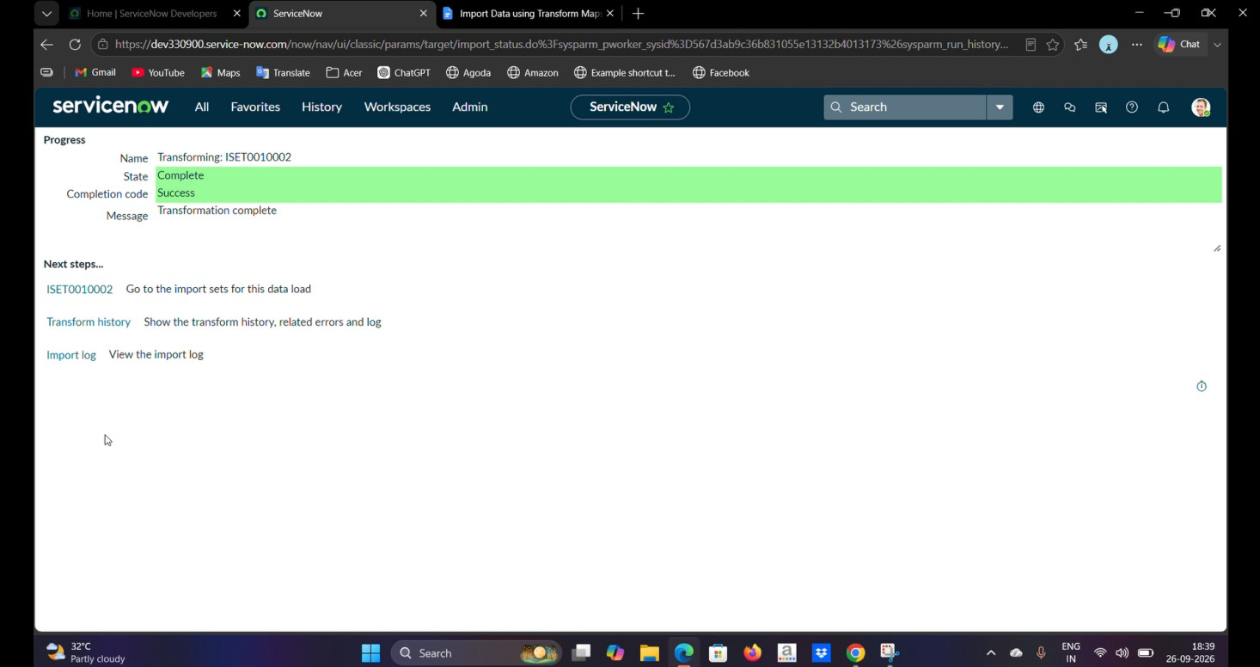
The Run Transform option is selected and the existing Transform Map is used.

The Transform History is then checked to identify:

- Inserted records
- Updated records
- Ignored records

In the sample project, four rows were uploaded. Two were inserted as new employee records and two existing records were updated. When the same sheet was imported again without changes, the records were ignored because there were no new changes to apply.
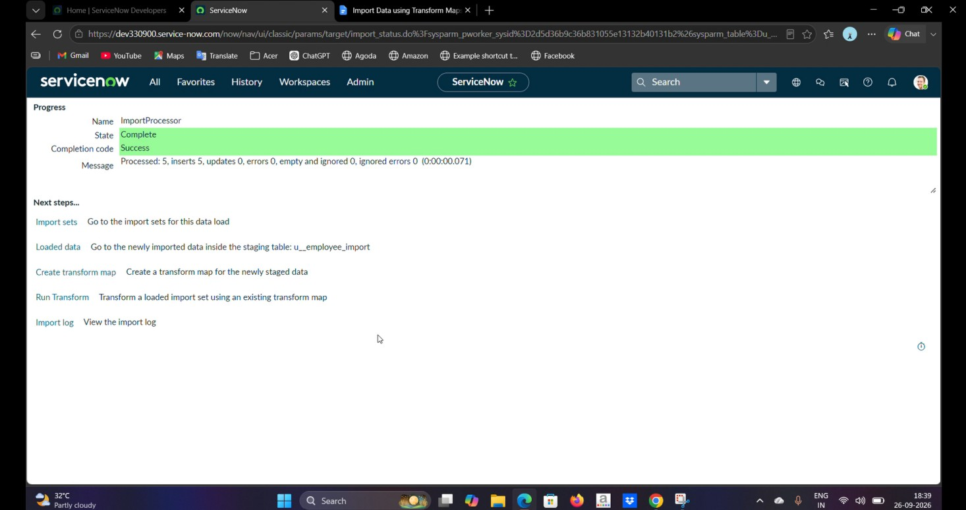

REPORTS

Three reports are created using the Employee Test table.

REPORT 1: EMPLOYEES BY DEPARTMENT

A Pie Chart is created to display the number of employees in each department.

Configuration:

- Report Name: Employees by Department
- Table: Employee Test
- Type: Pie Chart
- Group By: Department
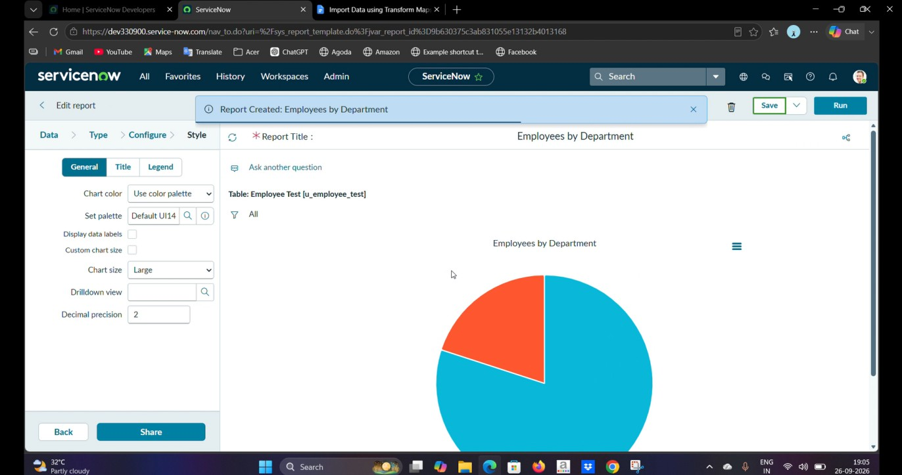
- Aggregation: Count

REPORT 2: EMPLOYEES BY LOCATION
- A Bar Chart is created to display employees based on their location.
- Configuration:
- Report Name: Employees by Location
- Table: Employee Test
- Type: Bar Chart
- Group By: Location
- Aggregation: Count

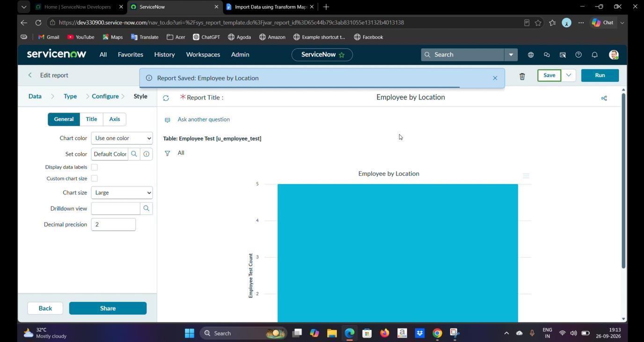

REPORT 3: EMPLOYEE LIST REPORT
- A List Report is created to display employee information in tabular form.
- Columns:
- Employee ID
- Employee Name
- Email
- Department
- Location

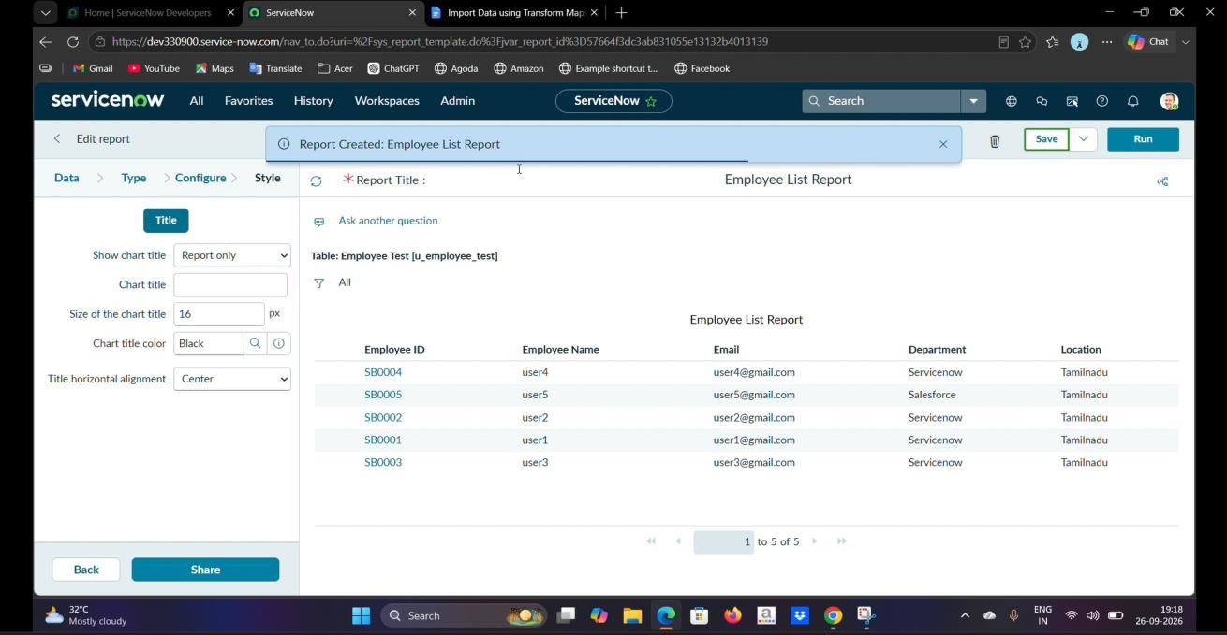

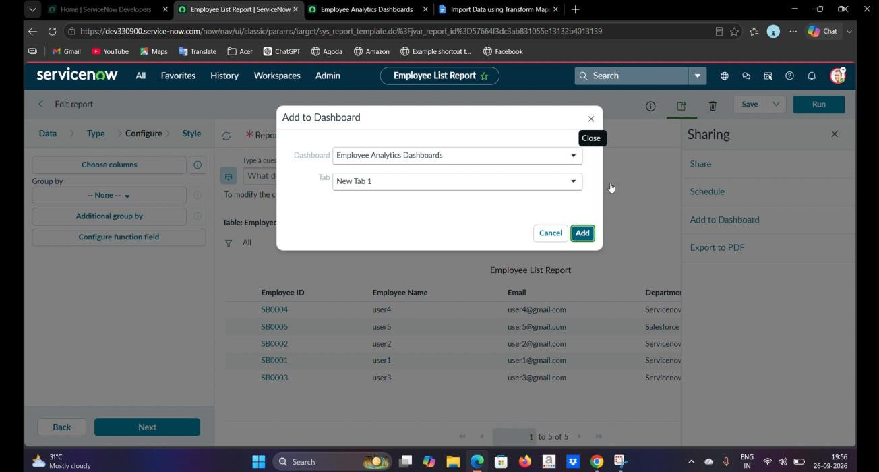

DASHBOARD
- A dashboard named Employee Analytics Dashboards is created in ServiceNow.
- The three reports are added to the dashboard:
- Employees by Department
- Employees by Location
- Employee List Report
- The dashboard provides a centralized view of employee information through charts and lists.

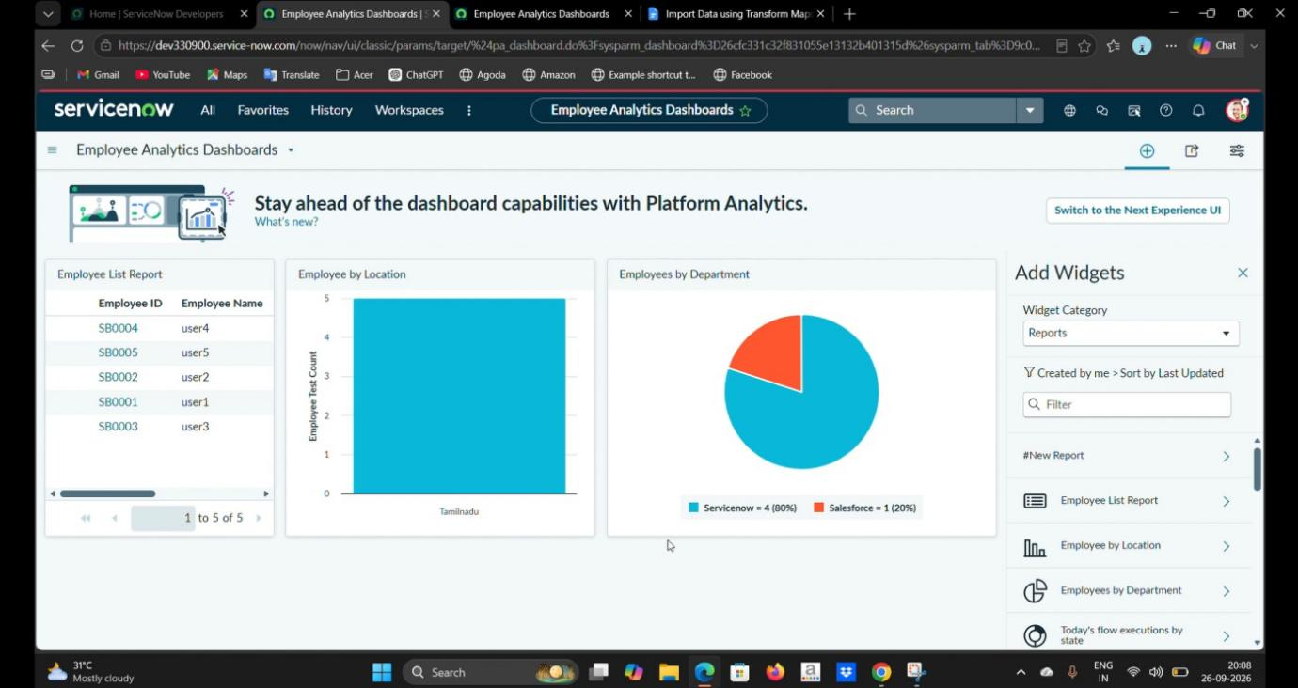

KEY FEATURES
- Excel data import
- Custom employee table
- Import Set processing
- Transform Map configuration
- Automatic field mapping
- Data transformation
- Coalesce-based duplicate prevention
- Insert and update handling
- Transform History verification
- Department-wise reporting
- Location-wise reporting
- Employee list reporting
- Centralized dashboard visualization

APPLICATIONS
- This project can be useful for:
- Employee data migration
- HR data management
- Bulk record creation
- Data synchronization
- Updating existing employee records
- Preventing duplicate records
- Employee data reporting
- Administrative data management

PROJECT OUTCOME
- The project successfully demonstrates the complete process of importing employee data from an external spreadsheet into ServiceNow using Import Sets and Transform Maps.
- The implementation also demonstrates how Coalesce can be used to prevent duplicate records and how Reports and Dashboards can provide meaningful visibility into employee data.

CONCLUSION
- The Import Data using Transform Maps project provides an efficient approach for importing and managing employee data in ServiceNow.
- The project successfully implements spreadsheet data loading, Import Sets, Transform Maps,

field mapping, data transformation and validation. Coalesce improves data integrity by preventing duplicate records and allowing existing records to be updated when appropriate.
- The project is further enhanced through Reports and Dashboards, which provide a centralized view of employee information and help administrators analyze employee data more easily.

